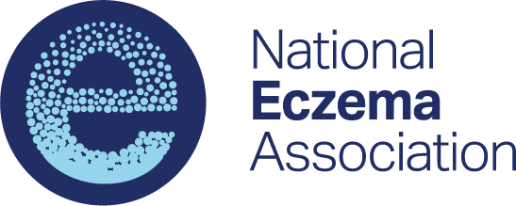

Research Grant
Interim Scientific Report

A report of scientific progress on the research project is due within thirty (30) days of the mid-point of the grant award period. Failure to meet this requirement will result in withholding of the 2nd installment of grant funds until the report is submitted and may result in early termination of the award. An additional interim report may be requested at NEA’s discretion based on reported progress toward project specific aims.

Email completed reports to Wendy Smith Begolka, MBS, SVP, Scientific and Clinical Affairs:
grants@nationaleczema.org

Name of Awardee:
Institution:
Title of Project:
Award Start Date: Report Submission Date:

Please provide a response to each of the following areas, keeping the total of all responses to 2-3 pages.
- Study Overview
Provide a concise description of study aims, methods, and potential value of any study findings to researchers, clinical care and patients.

- Progress to Date
Describe the progress and study results to date related to the outlined specific aims. Include tables and figures as appropriate.

- Summary of Remaining Work to Complete Study
Provide an overview of outstanding research or analyses and approximate timeline for completion.

- Publications and Meeting Abstracts
List any abstracts or manuscripts submitted or published based upon the results of this study.

